Visualizing Multi-Dimensional WMS within ArcGIS For JavaScript API

# Data Prep:

1. Obtain a netCDF File with a time dimension and another dimension. For example depth, altitude…
2. Open ArcGIS Desktop
3. Use “Make NetCDF Raster Layer” tool, within the Multidimensional Tools toolbox.

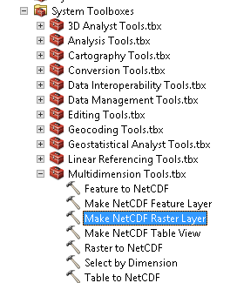

1. Browse to netCDF File
   1. X Dimension, Y Dimension should prepopulate
   2. Choose a variable.
2. For Dimension Values, choose every dimension you want represented within the WMS. i.e. time, depth
   1. IMPORTANT: This is a new workflow… In previous versions you would not choose time as a dimension. You would handle that within the time properties of the layer. In this case, we are not doing using time as a parameter. We want to use time as a dimension, so that all the time slices are described within the GetCapabilities file.
   2. Choose a default value
   3. Click Ok
3. Once tool finishes running, layer is displayed within Map Document.

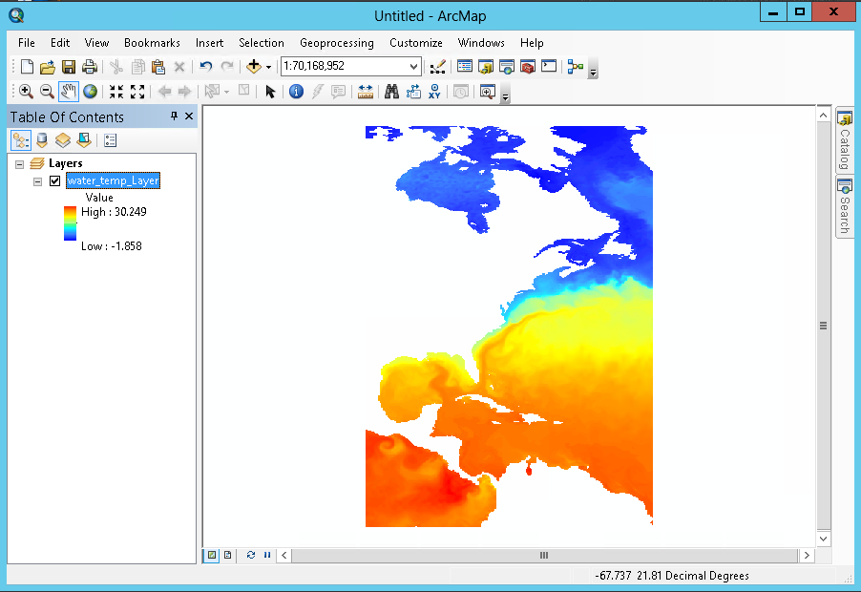

1. We are now ready to publish
2. Go to File🡪Share As🡪Service

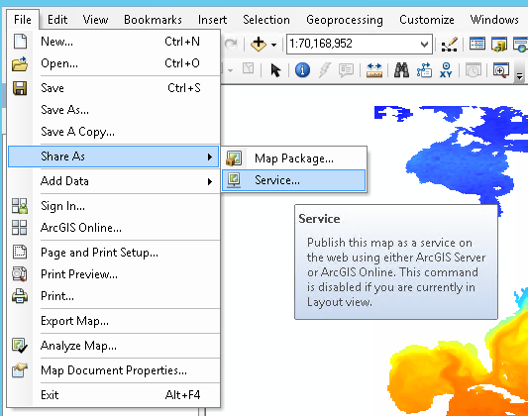

1. This Opens the publishing\Sharing Wizard
   1. Choose Publish a Service Click Next
   2. Choose an ArcGIS Server: MUST BE 10.2.1 or greater
   3. Give the Service a Name… Click Next
   4. Choose A folder Click Next
2. Now we are within the Service Editor
   1. Choose Capabilities
   2. Check the WMS Check Box
   3. Click Publish

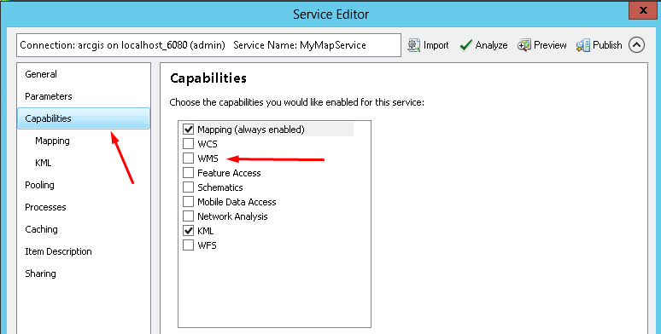

1. We now have a service, which contains WMS. The dimensions are described within the GetCapabilities file.

# The WMS Service:

## Accessing the WMS Service

1. Browse to the REST end point of the ArcGIS Service…
   1. For example: <http://ec2-23-20-2-145.compute-1.amazonaws.com:6080/arcgis/rest/services/netCDF/WaterTempMultiDim/MapServer/>
2. In the upper left hand corner there is a link to the WMS GetCapabilities file.

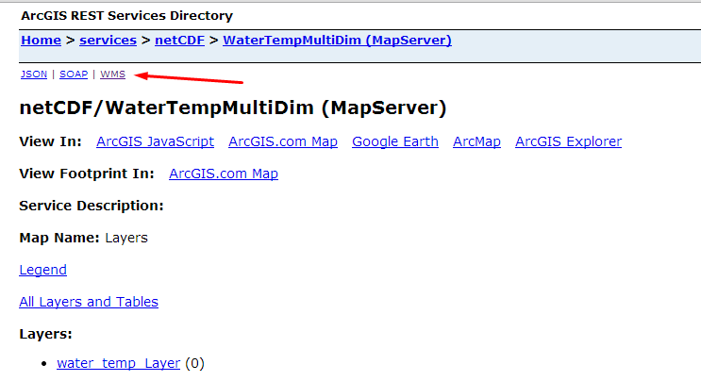

1. Click the Link

## Describing the Dimensions

1. Within the GetCapabilities file, scroll down to the layer definitions, and take a look at the dimensions.
2. Notice each dimension that was selected when building the netCDF Raster Layer is described here. Also, all the dimension values are also described.

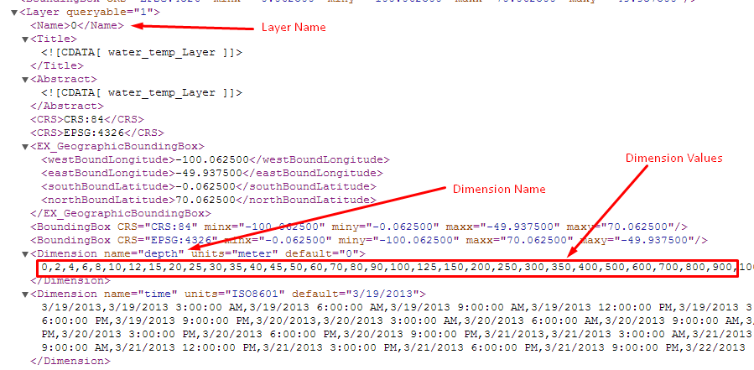

1. It is important to have the dimension values. That way the application knows which dimension values can be accessed.

## Using the GetMap Request

1. To display the GetMap Request, you must enter a ‘dim_’ in front of the dimension name. This is according the WMS specification. Also, if you just use ‘time’ instead of ‘dim_time’ the WMS is going to use ‘time as a parameter’ not as a dimension.
2. Here is an example GetMap Request:
3. http://ec2-23-20-2-145.compute-1.amazonaws.com:6080/arcgis/services/netCDF/WaterTempMultiDim/MapServer/WMSServer?request=GetMap&transparent=true&format=image%2Fpng&bgcolor=ffffff&version=1.1.1&layers=0&styles=default&exceptions=application%2Fvnd.ogc.se_xml&**dim_depth=0**&**dim_time=3%2F19%2F2013**&bbox=-16101557.276936032%2C-605807.142409293%2C3622864.9979918674%2C10352205.23255065&srs=EPSG%3A102100&width=1008&height=560
4. Notice how the dim_time is represented the same way as it is within the GetCapabilities file.
   1. ‘dim_time=3/19/2013’

# Using the NetCDF WMS with n Dimensions JavaScript Application

1. A working version of the application can be found here:
   1. <http://dtc-sci01.esri.com/MultiDimWMSViewer/>
2. The source code of the application is on GitHub here:
3. This application lets load a WMS with multiple dimensions (time +1 other) into a web application. The application uses the getcapabilities file to get all the unique time slices and other dimensions slices. Then displays both of those dimensions on a slider. The user can choose which dimension combination to use. When they select a specific dimension, the application updates the layer to draw\display that dimension.
4. This is the opening screen of the application

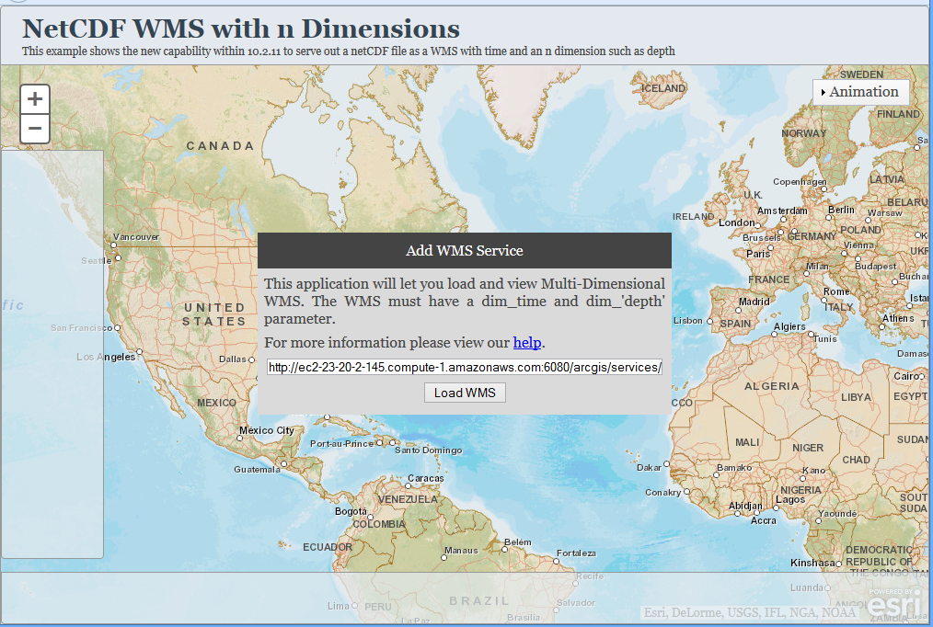

1. Copy and Paste your WMS service into the text box, or use the default text box
2. Click Load WMS
   1. Application hits the get capabilities file, gets all the information it needs and then displays it within the application
   2. **NOTE: Only currently works for the first layer within the WMS.**
   3. **NOTE 2: This particular step requires a PROXY file.**
3. Notice the widgets on the bottom and left of the application. These slider bars let you interact with the map.

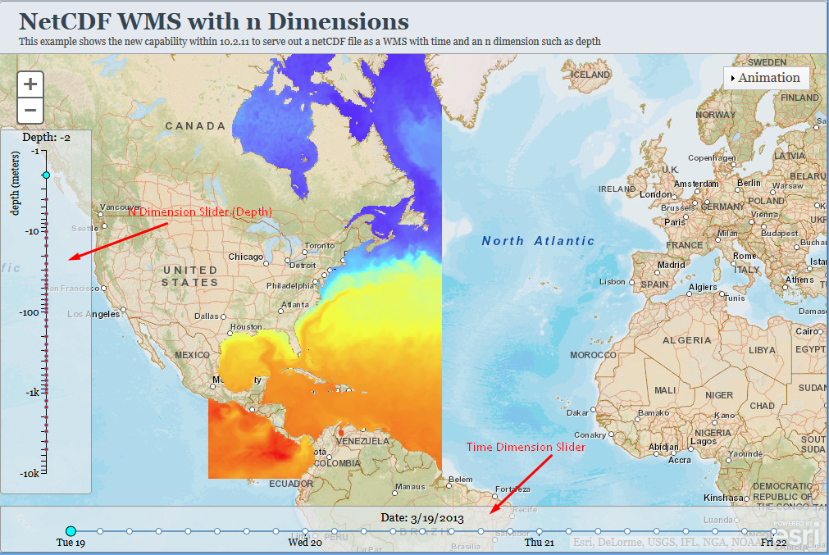

1. The titles show you the currently selected dimension value

## Time Slider



1. The Time Slider uses a Time Axis. Therefore the points are plotted where they would exist on the slider. If you have unequally spaced time-slices, there will be represented that way.
2. The title displays the value as it existed in the netCDF File and getcapabilities file.
   1. Note: ‘Date’ should be renamed to the dimension name. This still needs to be implemented.
3. Hover over one of the slider points. Notice it will expand and show you the value that the point contains.



1. Click on a Point on the Chart.
   1. The new point is now selected, the Title updates with the selected date, the WMS Layer within the map updates to the display the new time-selection

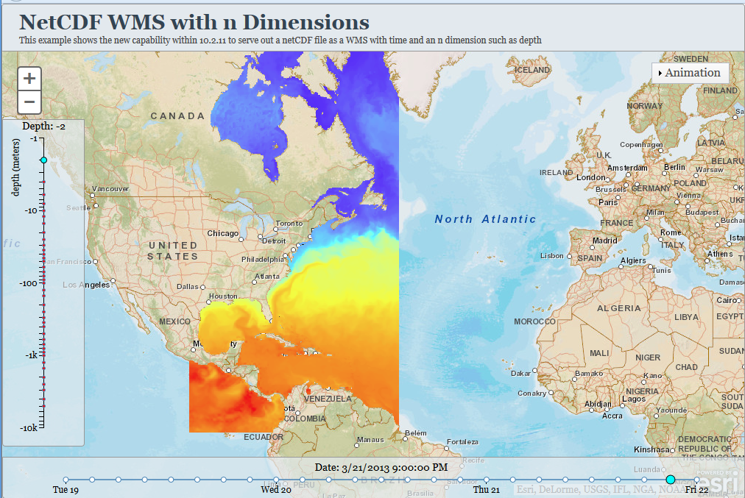

## N Dimension Slider

1. The n dimension slider works very similarly to the time slider.
2. The header\title contains the dimension name and value.
   1. NOTE: Depth may be hard coded, still need to update that
3. There is also a description on the upper left side ”depth (meters)”. This represents the dimension name and the dimension unit.
   1. NOTE: This is also hard coded currently, still need to implement that.
4. Notice the depth values are displayed using a Logarithmic chart.
   1. We are currently hard coding this to be a log chart, however, in the future, we may let the user decide to either view it in a log chart or a linear chart.
5. The rest of the chart functions like the time slider. Hover over an item, it gets larger and displays a tooltip with the value. Select the depth and the map updates with the new depth.

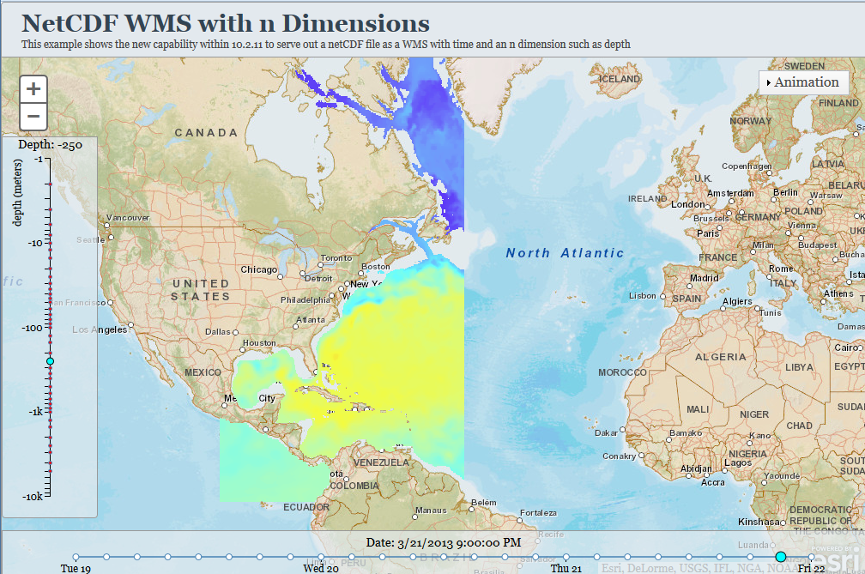

# The Source Code:

1. The source code will be put up on github for anyone to access.

## WMSLayerwTime Class:

1. Please view the code for reference…
2. We wrote our own WMS class for this particular application, because the WMSLayer class, does not handle dimensions.
3. This class extends the DynamicMapServiceLayer.
4. It overwrites the getImageUrl function and builds its own URL from the parameters object

getImageUrl: function(extent, width, height, callback) {

this.paramsOb.bbox = extent.xmin + "," + extent.ymin + "," +

extent.xmax + "," + extent.ymax;

this.paramsOb.srs = "EPSG:" + extent.spatialReference.wkid;

this.paramsOb.width = width;

this.paramsOb.height = height;

callback(this.wmsURL + "?" + dojo.objectToQuery(this.paramsOb));

}

1. The class also contains a couple methods to Initialize the Dimensions, which queries the GetCapabilities file to get the dimensions, dimension values, and dimension properties.
2. Once it finishes parsing the getcapabilities file for the dimension information, it fires off a “WMSDimensionLoaded” event.
   1. This event lets the client\developer know, that it’s ready to load the WMS Layer, and the dimensions can accessed through the class.
3. The dimensions can be retrieved through the WMSLayerWithTime.getDimensions() method.
   1. This returns an array of the dimensions
4. The dimension properties such as default value, units ect, can be retrieved through the WMSLayerWithTime.getDimensionProperties() method.
   1. This requires an input of the dimension name, as gotten from the getDimensions() method
   2. It outputs an object with name, units, default value. The name is the actual dimension name, not the WMS representation i.e. dim_<name>.
5. The dimension values can be retrieved using the WMSLayerWithTIme. wmsLayerGetDimensionValues() method.
   1. This requires an input of the dimension name, as gotten from the getDimensions() method
   2. The output is an array of string values representing each dimension value

## Adding WMSLayerWithTime to the Map

1. First create a map object using the Esri ArcGIS For JavaScript API:

require(["esri/map", "dojo/domReady!"], function(Map) {

map = new Map("map", {

center: [-56.049, 38.485],

zoom: 3,

basemap: "streets"

});

});

1. Get the WMS URL from the Text Box within the Splash Screen and use it within the constructor of the WMSLayerWithTime class.

var wmsURL = document.getElementById('wmsTextInput').value;

wmsLayer = new WMSLayerWithTime(wmsURL);

1. Be sure add an event listener so that know when the Get Capabilities file has been parsed and is ready to be used.

document.addEventListener("WMSDimensionsLoaded",wmsLoaded,false);

1. Once the event is fired off, initialize and add it to the map.

//Set Initial Values

wmsLayer.initializeDimensionParams();

map.addLayer(wmsLayer);

## Populating Dimension Sliders:

eventSliderOb = new EventSlider();

document.addEventListener("EventSliderDateChanged",updateMapTime,false);

var dimensions = wmsLayer.getDimensions();

for(index = 0; index < dimensions.length; index++)

{

var dim = dimensions[index];

if(dim.indexOf("time") != -1 || dim.indexOf("date") != -1 )

timeDim = dim;

else

nDim = dim;

}

var timeValues = wmsLayer.getDimensionValues(timeDim);

eventSliderOb.setTimeSlices(timeValues);

eventSliderOb.generateChart();